**Q1.Allocate Static IPs to all VM's Creating a Network Security Group Creating Public IP Associating/De-associating Public IP with virtual machine Creation of Network Interface**

Ans. **Allocate Static IPs to all VMs**

1. Log in to the Azure portal (https://portal.azure.com/) with your Azure account credentials.
2. Navigate to the Virtual machines blade by clicking on "Virtual machines" in the left-hand menu.
3. Select the virtual machine for which you want to allocate a static IP.
4. Click on the Networking tab.
5. Click on the IP configurations tab.
6. Click on the Edit button next to the IP configuration.
7. Select Static as the assignment method.
8. Enter the desired static IP address in the IP address field.
9. Click Save to save the changes.

**Create a Network Security Group**

1. Log in to the Azure portal (https://portal.azure.com/) with your Azure account credentials.
2. Navigate to the Network security groups blade by clicking on "Network security groups" in the left-hand menu.
3. Click on the + Create network security group button.
4. Enter a name and resource group for the network security group.
5. Select a location for the network security group.
6. Click Create to create the network security group.

**Create a Public IP**

1. Log in to the Azure portal (https://portal.azure.com/) with your Azure account credentials.
2. Navigate to the Public IP addresses blade by clicking on "Public IP addresses" in the left-hand menu.
3. Click on the + Create public IP address button.
4. Enter a name and resource group for the public IP address.
5. Select a location for the public IP address.
6. Choose the Dynamic or Static assignment method.
7. Click Create to create the public IP address.
8. Associate/De-associate Public IP with Virtual Machine

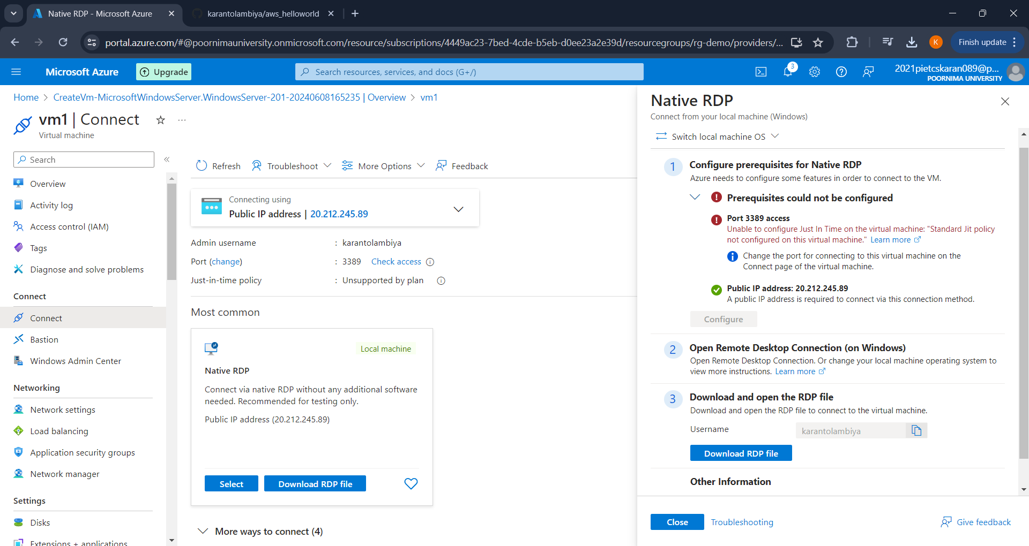

**Create a virtual machine**

1. Navigate to the Virtual machines blade by clicking on "Virtual machines" in the left-hand menu.
2. Select the virtual machine for which you want to associate or de-associate a public IP.
3. Click on the Networking tab.
4. Click on the IP configurations tab.
5. Click on the Edit button next to the IP configuration.
6. Select the public IP address you want to associate or de-associate from the Public IP address dropdown menu.
7. Click Save to save the changes.
8. Create a Network Interface
9. "Network interfaces" in the left-hand menu.
10. Click on the + Create network interface button.
11. Enter a name and resource group for the network interface.
12. Select a location for the network interface.
13. Choose the Virtual network and Subnet for the network interface.
14. Click Create to create the network interface.

